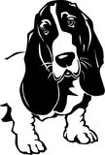
Morning Glory
NDOG
Kidz Klub
Muffins

1) Preheat oven to 350 degrees F. Grease 12 muffin cups, or line with paper muffin liners.
2) In a large bowl mix together the following ingredients.
2 cups all-purpose flour
2 teaspoons ground cinnamon
1 ¼ cup white sugar
¼ teaspoon salt
2 teaspoons baking soda
3) Stir in the following ingredients.
2 cups shredded carrots
½ cup unsweetened, flaked coconut
½ cup golden raisins
1 apple – peeled, cored and shredded
½ cups chopped walnuts, optional
4) In a separate bowl beat together:
3 eggs
1 cup vegetable oil
2 teaspoons vanilla extract
5) Stir egg mixture into the carrot/flour mixture just until moistened.
6) Scoop batter into prepared muffin cups.
7) Bake in preheated oven for 20 minutes or until a toothpick inserted into the center of a muffin comes out clean.
Recipe contributed by Howard County Farmer’s Market Co-Manager Mary Hartness

Morning Glory
NDOG
Kidz Klub
Muffins

1) Preheat oven to 350 degrees F. Grease 12 muffin cups, or line with paper muffin liners.
2) In a large bowl mix together the following ingredients.
2 cups all-purpose flour
2 teaspoons ground cinnamon
1 ¼ cup white sugar
¼ teaspoon salt
2 teaspoons baking soda
3) Stir in the following ingredients.
2 cups shredded carrots
½ cup unsweetened, flaked coconut
½ cup golden raisins
1 apple – peeled, cored and shredded
½ cups chopped walnuts, optional
4) In a separate bowl beat together:
3 eggs
1 cup vegetable oil
2 teaspoons vanilla extract
5) Stir egg mixture into the carrot/flour mixture just until moistened.
6) Scoop batter into prepared muffin cups.
7) Bake in preheated oven for 20 minutes or until a toothpick inserted into the center of a muffin comes out clean.
Recipe contributed by Howard County Farmer’s Market Co-Manager Mary Hartness

For more information about activities at Howard County Farmers’ Market and Nashville Demonstration Organic Garden check the Farmers’ Market page at nashvillear.com/attractions/farmers market
and Howard County Farmers’ Market on Facebook . . . or contact:

Farmers’ Market Co-Managers:
Debra Bolding (870) 557-2352
Mary Hartness (501) 472-8092
NDOG Coordinator:
Gerry Wenta (903) 278-6716
NDOG Kidz Klub Coordinator:
Sherry Wenta (870) 845-0134
NDOG Square-Foot Garden Coordinator:
Rita Rector (870) 287-4573
NDOG Seed Swap Coordinator:
Pamela Rayburn (903) 490-1080
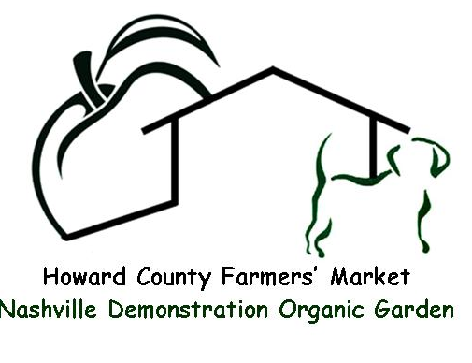

For more information about activities at Howard County Farmers’ Market and Nashville Demonstration Organic Garden check the Farmers’ Market page at nashvillear.com/attractions/farmers market
and Howard County Farmers’ Market on Facebook . . . or contact:

Farmers’ Market Co-Managers:
Debra Bolding (870) 557-2352
Mary Hartness (501) 472-8092
NDOG Coordinator:
Gerry Wenta (903) 278-6716
NDOG Kidz Klub Coordinator:
Sherry Wenta (870) 845-0134
NDOG Square-Foot Garden Coordinator:
Rita Rector (870) 287-4573
NDOG Seed Swap Coordinator:
Pamela Rayburn (903) 490-1080

